**Experiment No :** 09

**Experiment name :** Write a C program to print a full pyramid using star.

**Methodology :**

1. The outer loop will iterate through the rows of the pyramid.
2. The inner loop will print the spaces and stars for each row.

**Flow-Chart :**

int i , j , rows , star = 0 ;

**Code :**

printf("\n");

while(star !=(2*i+1))

star++;

printf(" ");

for(i=0 ; i<rows ; i++){

for(j=0; j<=(rows -i -1); j++)

Input row

scanf("%d",&rows);

star = 0 ;

printf("*");

#include<stdio.h>

int main(){

int i , j , rows , star = 0 ;

printf("Enter the number of rows : ");

scanf("%d",&rows);

for(i=0 ; i<rows ; i++){

for(j=0; j<=(rows -i -1); j++){

printf(" ");

}

//printing stars

while(star !=(2*i+1)){

printf("*");

star++;

}

star = 0 ;

//move to new row

printf("\n");

}

return 0 ;

}

**Output:**

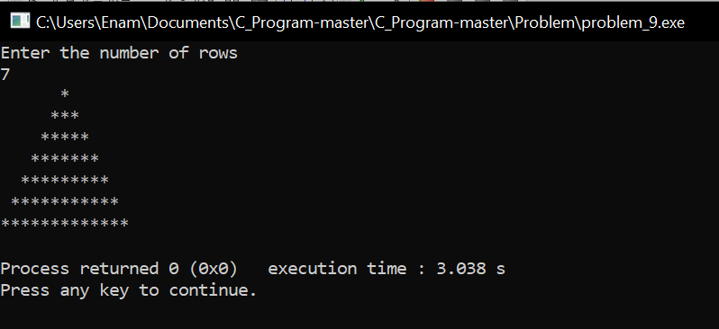

**Result discussion :**

Through this program we have seen how to create a full pyramid. We can create a full pyramid with any number of stars or numbers we want. We have used for and while loops to create it and then we have printed the entire pyramid using row.